

**Electrical and Computer Engineering Department**

**ECE 4700: Feedback Systems**

**Final Report: DC Elevator Feedback Controller**

**Michael J Sallmen**

**04/22/2018**

**Abstract**

The goal of this project is to design a simple process and learn the fundamentals of how a simple control system works. An elevator is a simple device that can be created to meet the requirements of this assignment. The elevator plant has been designed and can be seen in figure one below. The Buhler DC motor will be the actuator. The pulley, or the process, is being driven by the DC motor. The pulley will lift the mass up or down depending on which way the motor is moving. When a certain amount of voltage is applied to the DC motor this will cause the pulley to rotate to a specific floor.

Figure One:

Elevator Plant

PLANT

Pulley

(Process)

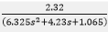

Buhler DC Motor

(Actuator)

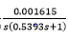

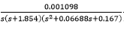

**System Analysis**

**Plant Transfer Function:**

The following transfer function for the plant as seen in the previous report is also shown below for the convenience of the reader, as it will be used throughout the report.

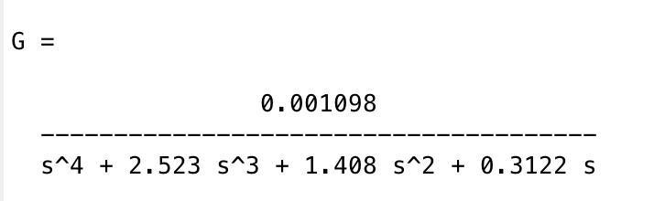

**Bode Analysis of the Plant:**

Bode diagram representing the plant (or open-loop system):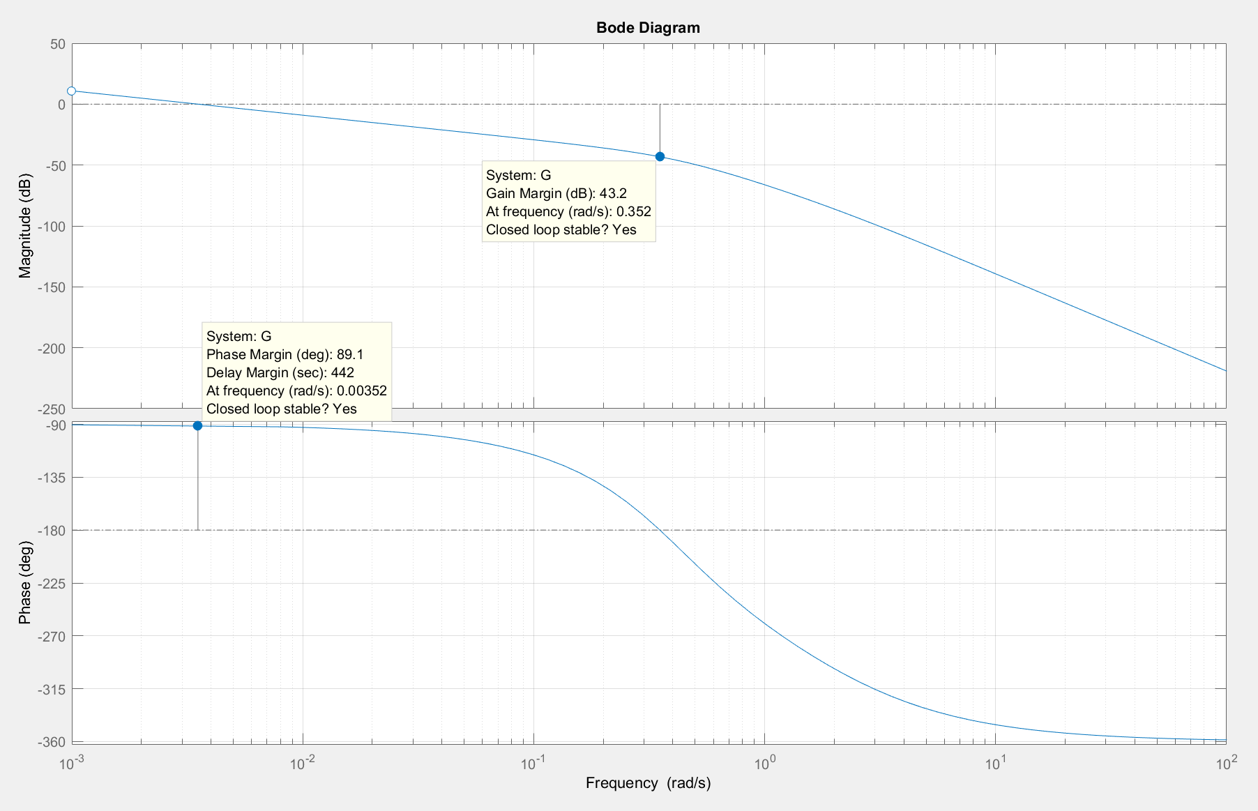e

Useful parameters that were obtained from the bode diagram of the plant contain the following:

* Gain Margin(GM) = 43.2dB
  + Gain margin is a parameter that represents the change in the open-loop gain that a system can last before becoming unstable, and due to a present gain margin existing in this system, it can be said that this open-loop system is stable.
* Phase Margin(PM) = 89.1dB
  + Phase margin represents the change in the open-loop phase shift that a system can last before becoming unstable. In addition to what was previously stated pertaining to the present GM in the system, there is also a present phase margin in this open-loop system, thus adding more evidence that this system is stable.
* Delay Margin = 442sec
* Gain Crossover Frequency = $ω_{gc}=$ 0.00352rad/sec
* Damping ratio = ζ $=\frac{PM}{100}=\frac{89.1}{100}=0.891$
* The system is stable.
* It can be further said that gain and phase margins are an excellent measurement of a system’s “robustness”.

The following bode plot is the same as the previous open-loop bode plot, but with a slight modification in MATLAB using margin(100*G) to display a more evenly distributed curve for both the magnitude and phase plots as seen below.

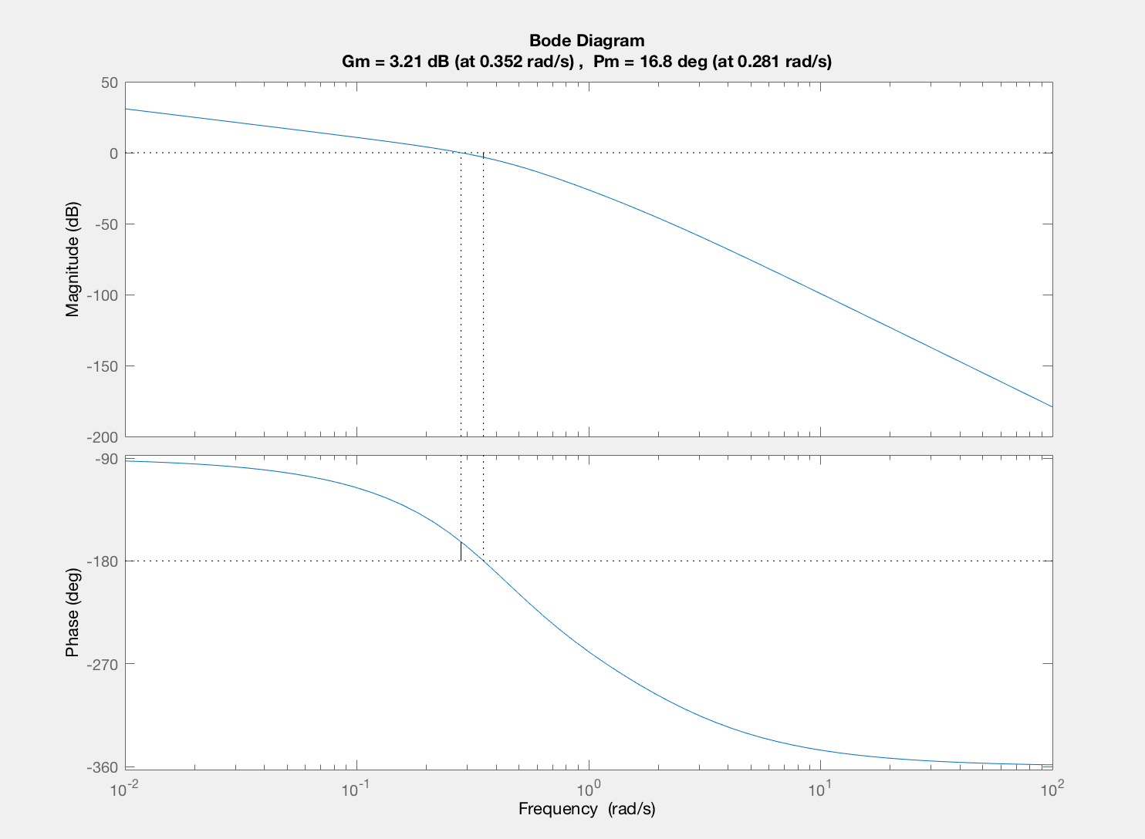

**Nyquist Analysis of the Plant:**

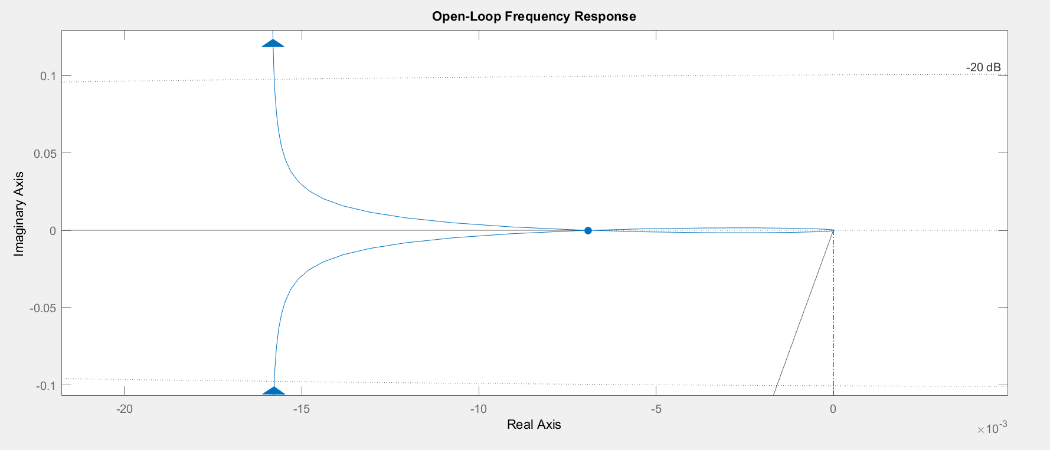

* GM = 43.2 dB
* Phase crossover frequency = $ω_{pc}$ = 0.352 rad/sec
* Gain crossover frequency = $ω_{gc}$ = 0.00352 rad/sec
* The System is stable.
* We can conclude that in comparing the Nyquist plot analysis with the Bode plot analysis of the plant, that the gain margins come out to equal 43.2dB with both methods of analysis, and thus both methods displayed stable responses as the result.
* Now in describing the system’s crossover frequencies, it is noted that the closed-loop system's phase margin is the additional amount of phase lag that is required for the open-loop system's phase to reach -180 degrees at the frequency where the open-loop system's magnitude is 0 dB (the gain crossover frequency, ). Likewise, the gain margin is the additional amount of gain (usually in dB) required for the open-loop system's magnitude to reach 0 dB at the frequency where the open-loop system's phase equals -180 degrees (the phase crossover frequency, $ω_{pc}$).

**Analysis of Closed-Loop System Using Frequency Techniques:**

Unity-feedback block diagram model:

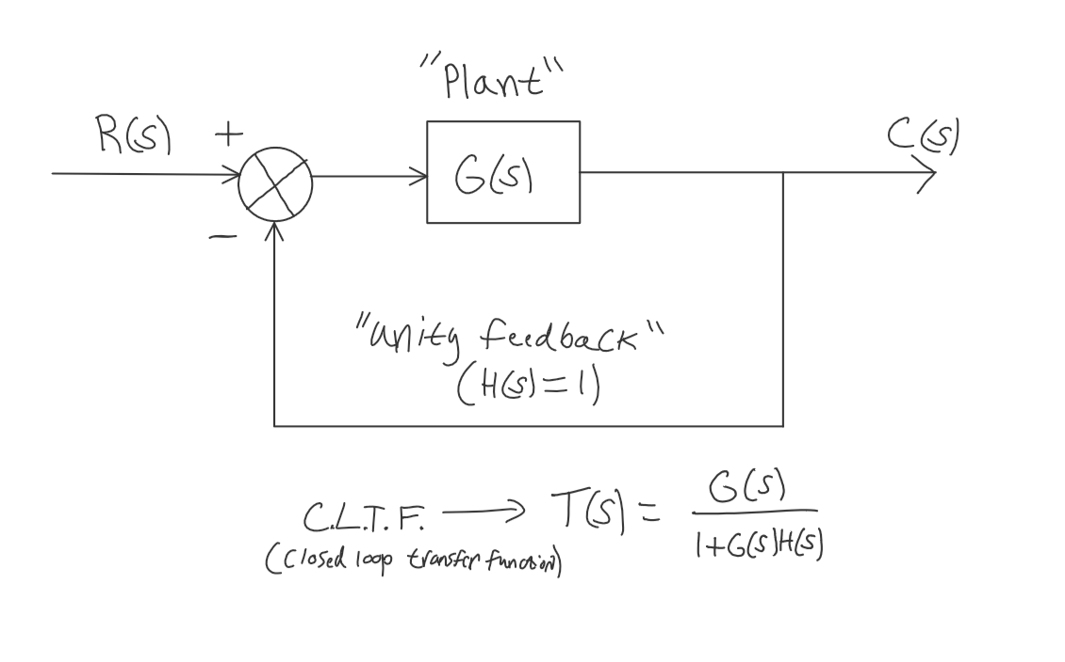

Closed-loop transfer function:



$$T\left(s\right)=\frac{0.001098}{\left(s^{4}+2.523*s^{3}+1.408*s^{2}+0.3122*s+0.001098\right)}$$

* The previous equation represents the closed-loop transfer function, which is derived from the unity feedback model above, where the closed-loop transfer function is given by $T\left(s\right)=\frac{G(s)}{1+G\left(s\right)*H(s)}$, where H(s)=1 representing unity feedback.

Bode Diagram for closed-loop transfer function:

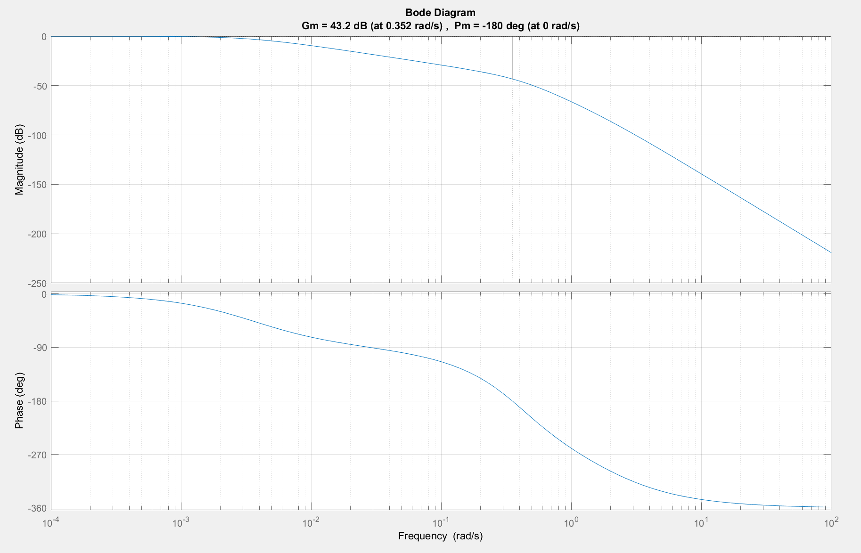

Useful measurements and conclusions were obtained from the bode diagram above which include:

* Gain Margin🡪 GM = 43.2 dB
* Phase Margin🡪PM = -180 degrees
* The Delay Margin is infinite
* Damping ratio = ζ $=\frac{180}{100}$ = 1.8
* Given that ζ > 1.8, we can conclude that the closed-loop system time response is overdamped, and this shows that the response is providing a very little overshoot which could potentially harm the riders of the elevator. This calls for the need for adding compensators into the system to provide more overshoot. More overshoot would enable a more comfortable and safe arrival for the passengers riding the elevator. The addition of compensators will be implemented during the system design, which will be seen later in this report.
* It follows that the **closed-loop system is stable**.

Time response for the closed-loop transfer function:

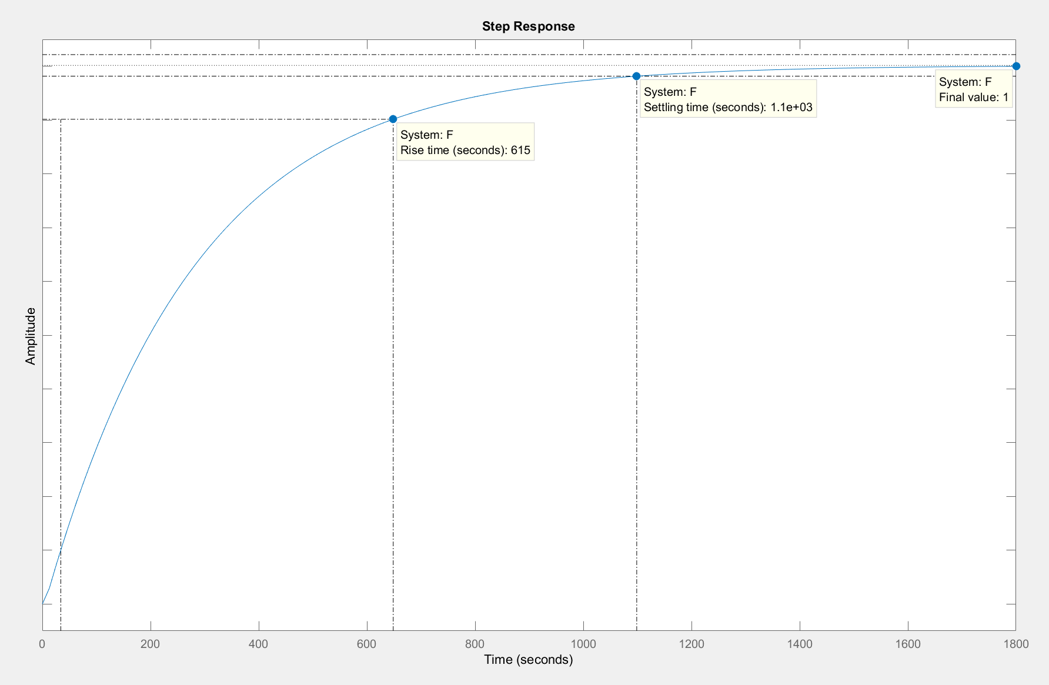

* Rise time = $T_{r}$ = 615s (Rise time is defined as the time it takes for one wave form to go from 0.1 to 0.9 of it’s final value)
* Settling Time = $T_{s}= 1100s$ (Settling time is the the time for the response to reach 2% of it’s final value.)
* It is evident and clear, that by using open-loop frequency response methods, we can make confident predictions of the system’s closed-loop time-response behavior. This response is justified by the previous output plot, that displays the time response for the closed-loop transfer function.

Closed-loop frequency response (contains two plots for this method):

* Bode plot of the closed-loop system: (the frequencies are the same here and so we will choose this point as our crossover for the phase.)

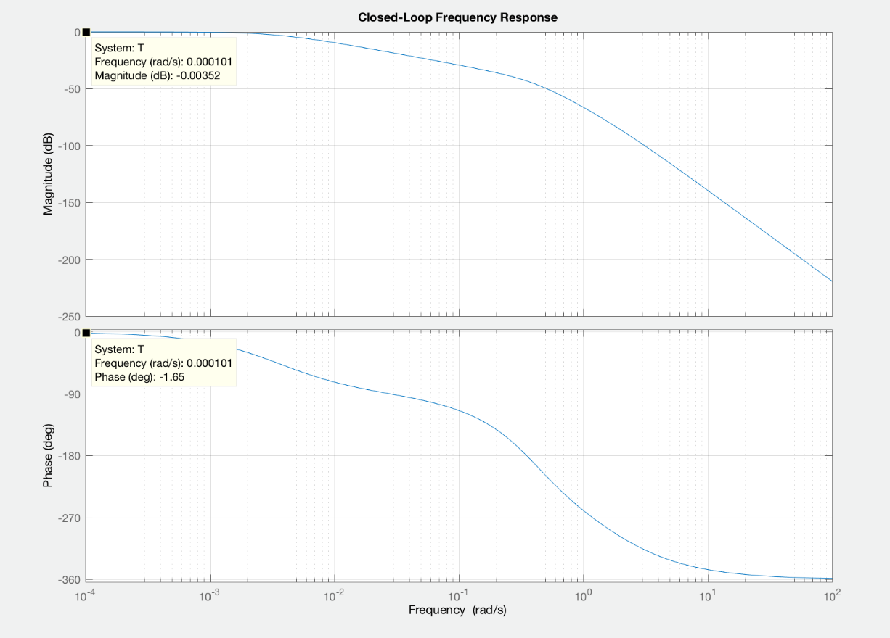

Nyquist plot:

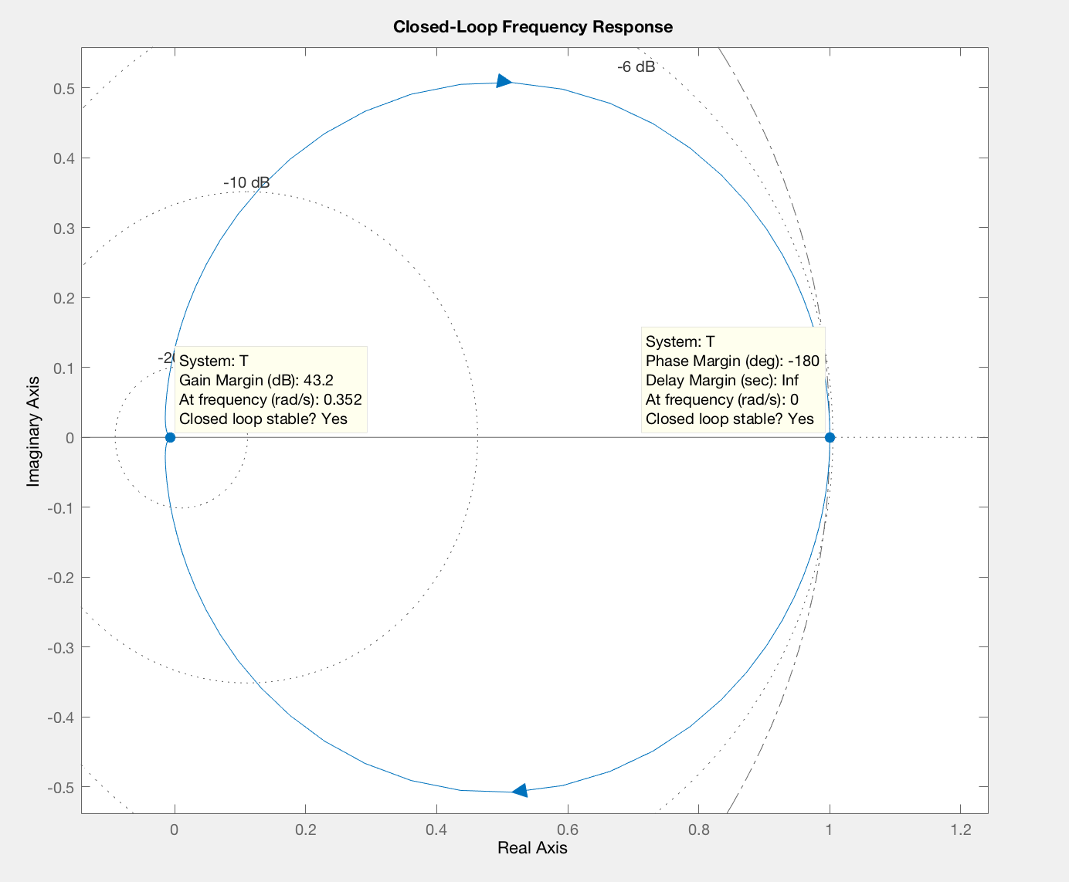

Notice how these values are exactly the same as with previous methods:

* GM=43.2 dB
* PM = -180 degrees
* Phase crossover frequency🡪 = 0.352 rad/sec
* Natural frequency 🡪 = 0.00202 rad/sec
* Bandwidth 🡪 = 0.000608 rad/sec
* The **closed-loop** system is stable.

**Investigation of the effects of time delays upon the system:**

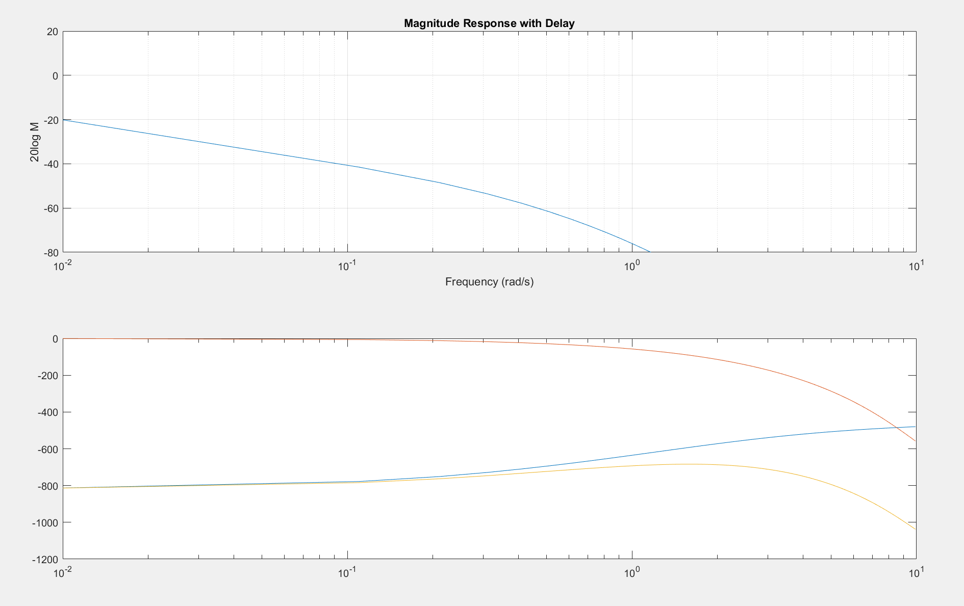

-One thing to note when dealing with a delay or a shift in time is that it directly corresponds to a change in phase in the frequency domain.

-Using phase information is an excellent tool that can be used to measure a systems time delay, especially if one has knowledge of the systems phase margin which can directly measure a system’s time delay. If there is a time delay greater than PM/W_gc in the loop (where W_gc is the frequency in rad/sec where the magnitude is 0 dB and PM is the phase margin converted to radians), the closed-loop system will become unstable. The time delay(τ), can be thought of as an extra block in the forward path of the functional block diagram that adds a phase lag to the system but has no effect on the gain. That is, a time delay can be represented as a block with the magnitude of 1 and phase -ωτ.

The plot below displays the systems closed-loop gain (K):

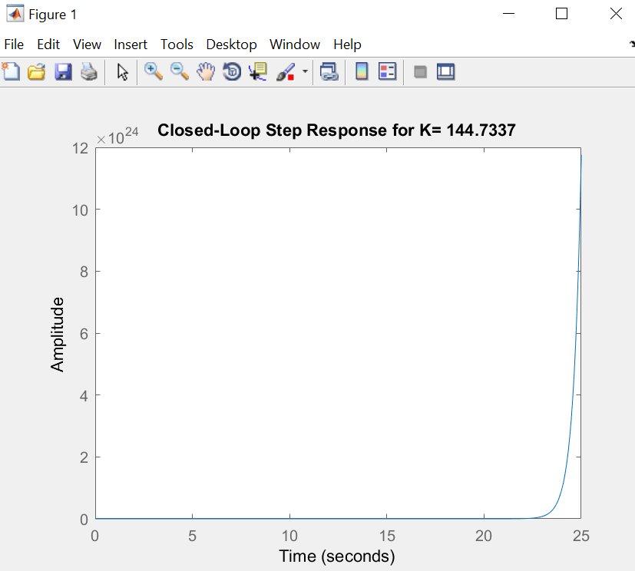

**System Design**

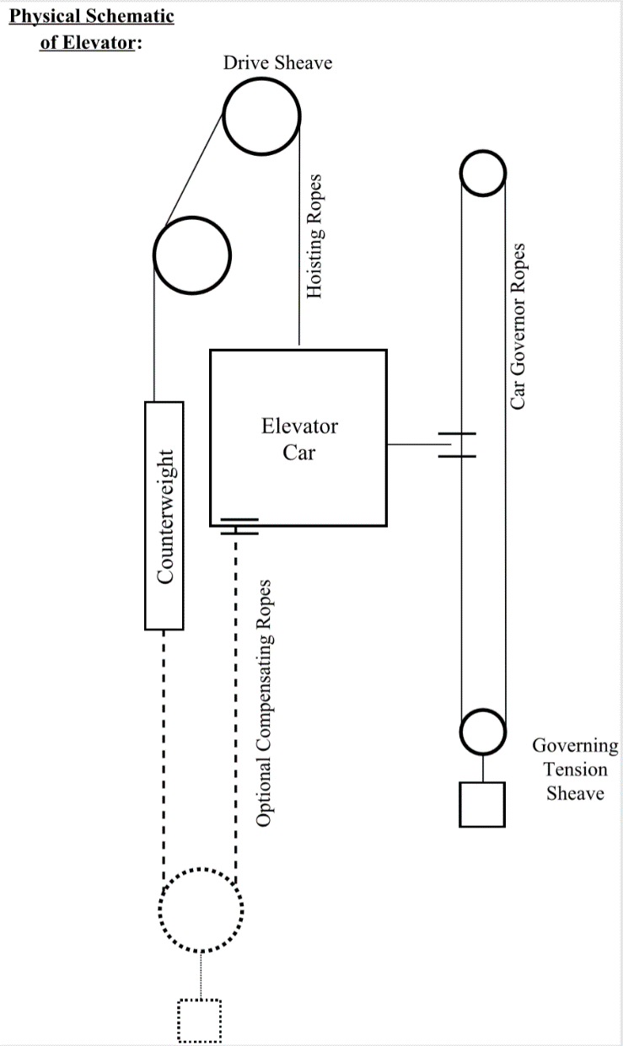The modern-day elevator system uses an actuator to drive a process, the process is normally a pulley and the actuator a DC motor, these two critical parts of the system exist in the forward path and make up the plant when cascaded together. The purpose of this system is for the positioning of the elevator and is accomplished by using a proper speed reference or pattern that provides the speed profile required to move the elevator car from the departure floor to the arrival floor in the minimum possible time with minimal discomfort to the passengers. The frequency techniques used for generating these patterns with system lag and lead compensation will be described in detail throughout the report, but first let’s consider the analysis and design of the uncompensated system.

Figure 0. *Generic physical configuration for the common elevator*

**Analysis of the Uncompensated System**

To better understand the uncompensated system during the design process, it is helpful to have a pictorial representation of the system including block diagrams and a physical model which are seen in the figures below.

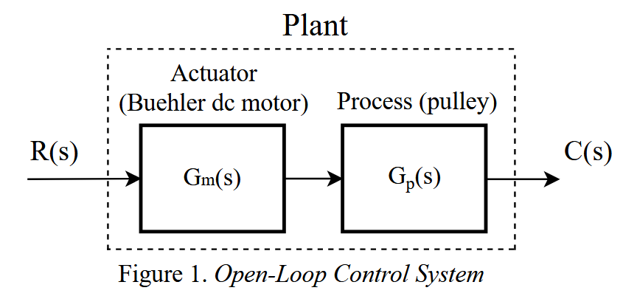

**Transfer function of the Actuator: $G_{m}\left(s\right)=\frac{0.001615}{s*(0.5393*s+1)}$**

**Transfer function of the Process: $G_{p}\left(s\right)=\frac{8}{42s^{2}+13s+12}$**

**Plant Transfer Function:**  

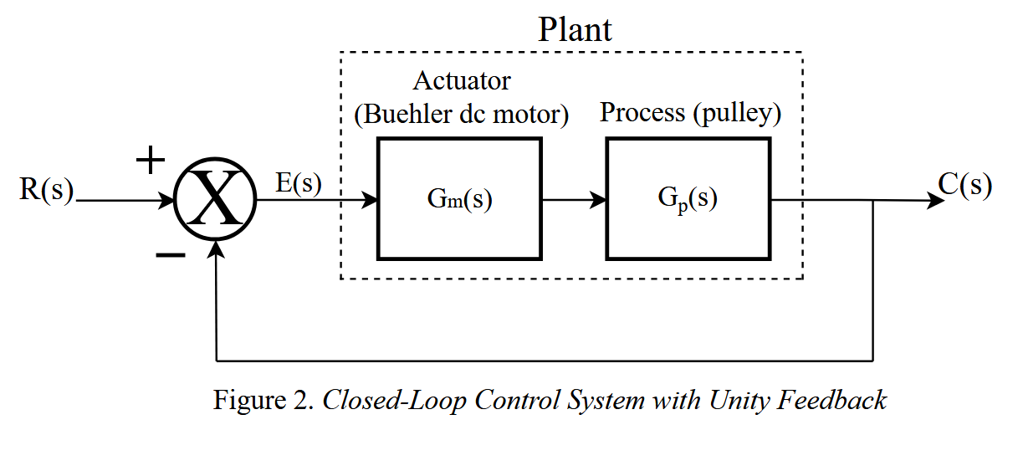

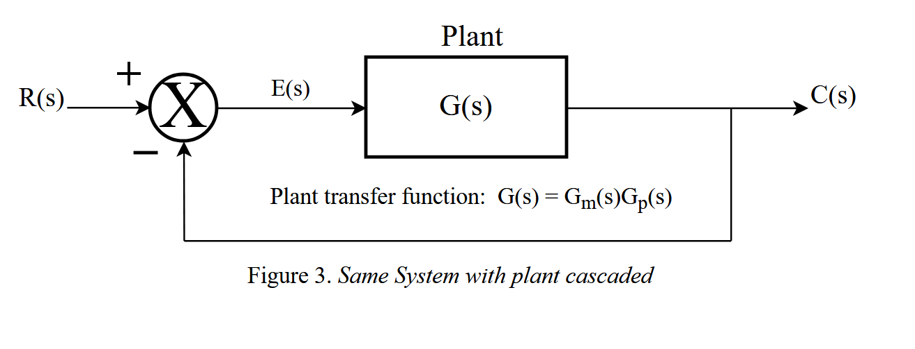

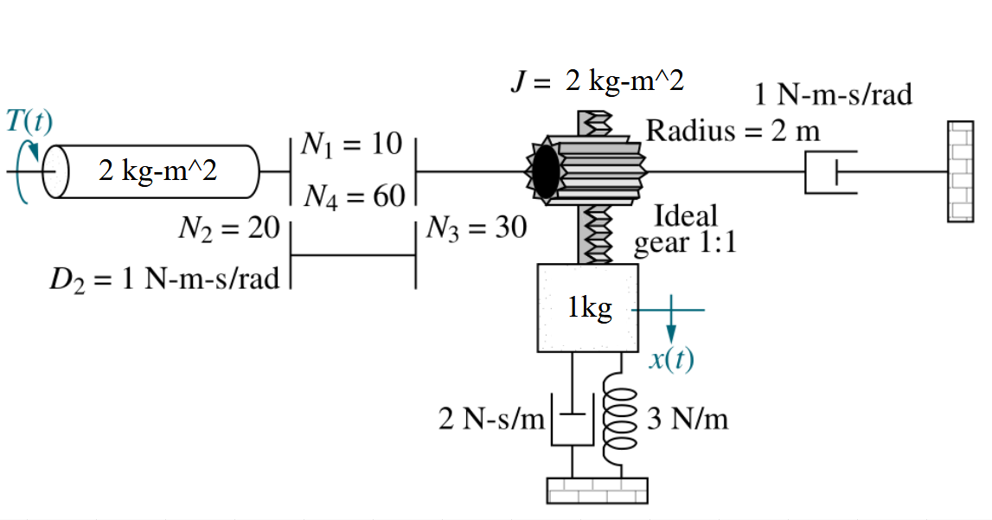

Figure 4.*Physical schematic of elevator system*

As seen previously in Figure 4, the elevator control system like in problem 2.43 of the Nise 7th edition text book was used. Please note that the values that I used during the design of the system differed from the textbook. Different values were used based on the real-life application that I would like to build an elevator in.

During the study of the uncompensated system, **open-loop frequency techniques** were used by the designer to gain information pertaining to the closed loop response. Bode analysis especially was one of the key tools for analyzing the system and resulted in providing the designer with direction and insight on what needed to be improved to meet specifications and design requirements for the compensated system design. System parameters that needed to be compensated for during the system design, included **steady state performance** and the **settling time** of the closed-loop response. Improvements will show later in the report that compensation of the system can be implemented to achieve specific design requirements and goals.

During the analysis of the uncompensated system, calculations of the **uncompensated static error constant of the plant to a ramp input** were made**.** This wasgiven by the equations below.

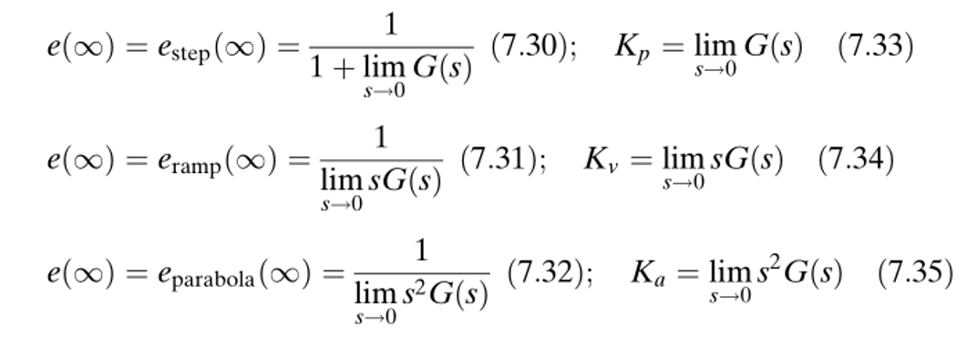



The steady state error calculated for a ramp input was found to be quite high for this **type 1 system**. If we increase  then this will result in decreasing the steady state error, since  and  are inversely proportional to each other. This verifies that the uncompensated system has provided evidence that the steady state performance needs to be a top priority in moving forward with the system design using compensators. Adding compensators to the system will be implemented later.

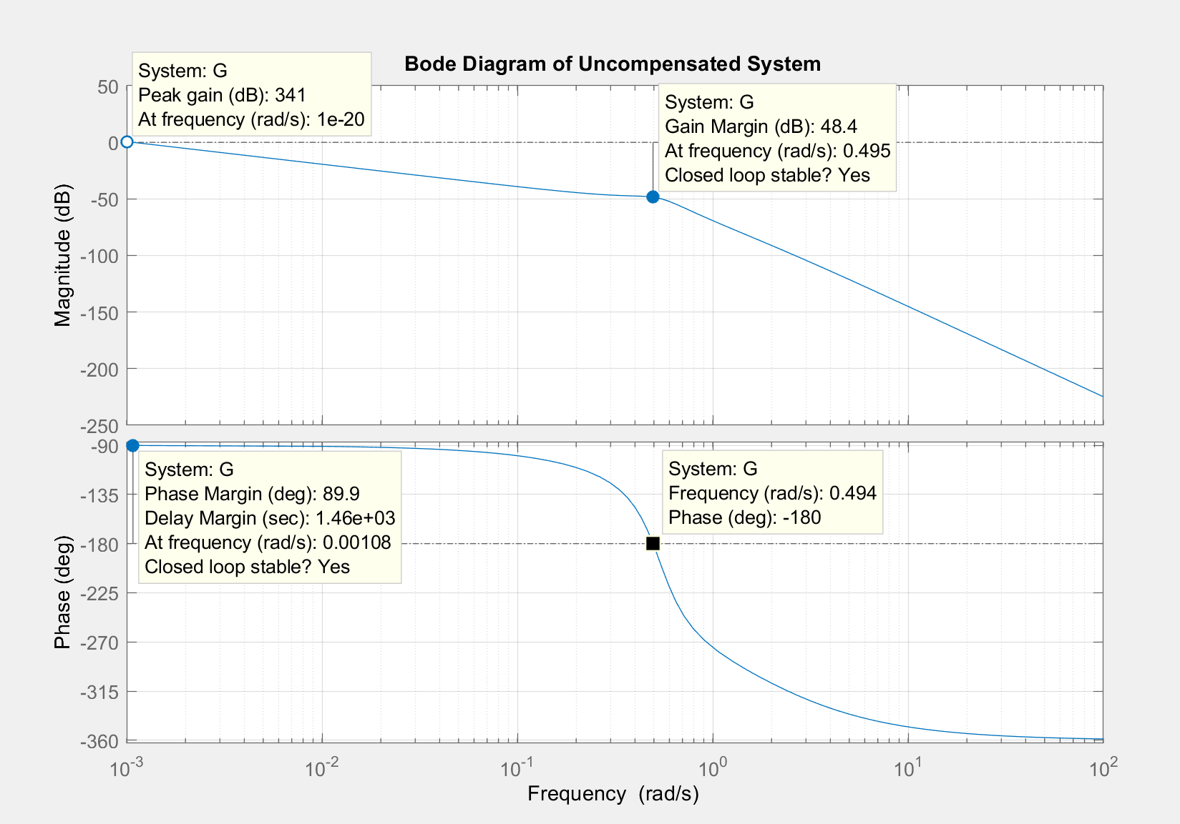

Figure 5. *Bode diagram representing the plant of the uncompensated system*

* **Gain Margin = 48.4 dB**
* Gain margin is a parameter that represents the change in the open loop gain that a system can stand before becoming unstable.
* **Phase Margin = 89.9 degrees**
* Phase margin represents the change in the open-loop phase shift that a system can last before becoming unstable. In other words, it measures how much phase variation is needed at the gain crossover frequency to lose stability.
* It can be further said that gain and phase margins are an excellent measurement of a system’s “robustness”. Together, these two numbers give an estimate of the "safety margin" for closed-loop stability.
* Delay Margin = 1460 sec
* Gain Crossover Frequency = $ω_{gc}=$ 0.001077 rad/sec
* The gain crossover frequency is the frequency “value” that occurs at 0 dB on the magnitude bode plot. What is phenomenal about this parameter $ω_{gc}$, is that it is equal to the steady state parameter $K_{v}$, that was previously solved for.

- **Phase Crossover Frequency** = $ω_{pc}=0.494$ rad/sec

- **Damping ratio =** **ζ $=\frac{PM}{100}=\frac{89.9}{100}=0.899$**

**- Percent overshoot = ** = = 0.1582 % overshoot

- The system is **stable**.

Figure 4. *Nyquist Analysis of the uncompensated open loop system*

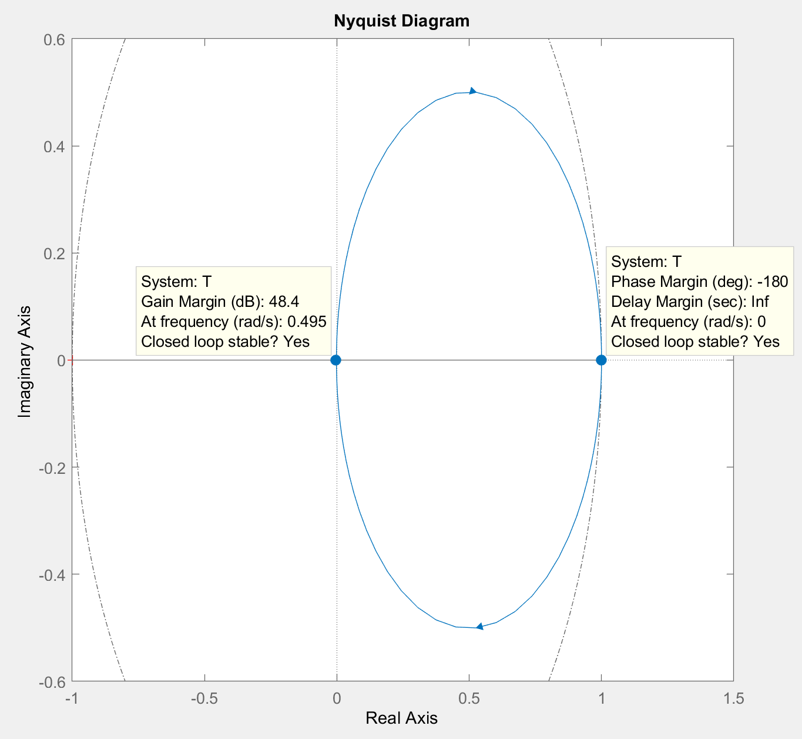

We can conclude that in comparing the Nyquist plot analysis with the Bode plot analysis of the plant, that the gain margins come out to equal 43.2dB with both methods of analysis, and thus both methods displayed stable responses as the result.

Now in describing the system’s crossover frequencies, it is noted that the closed-loop system's phase margin is the additional amount of phase lag that is required for the open-loop system's phase to reach -180 degrees at the frequency where the open-loop system's magnitude is 0 dB (the gain crossover frequency, ). Likewise, the gain margin is the additional amount of gain (usually in dB) required for the open-loop system's magnitude to reach 0 dB at the frequency where the open-loop system's phase equals -180 degrees (the phase crossover frequency, $ω_{pc}$).

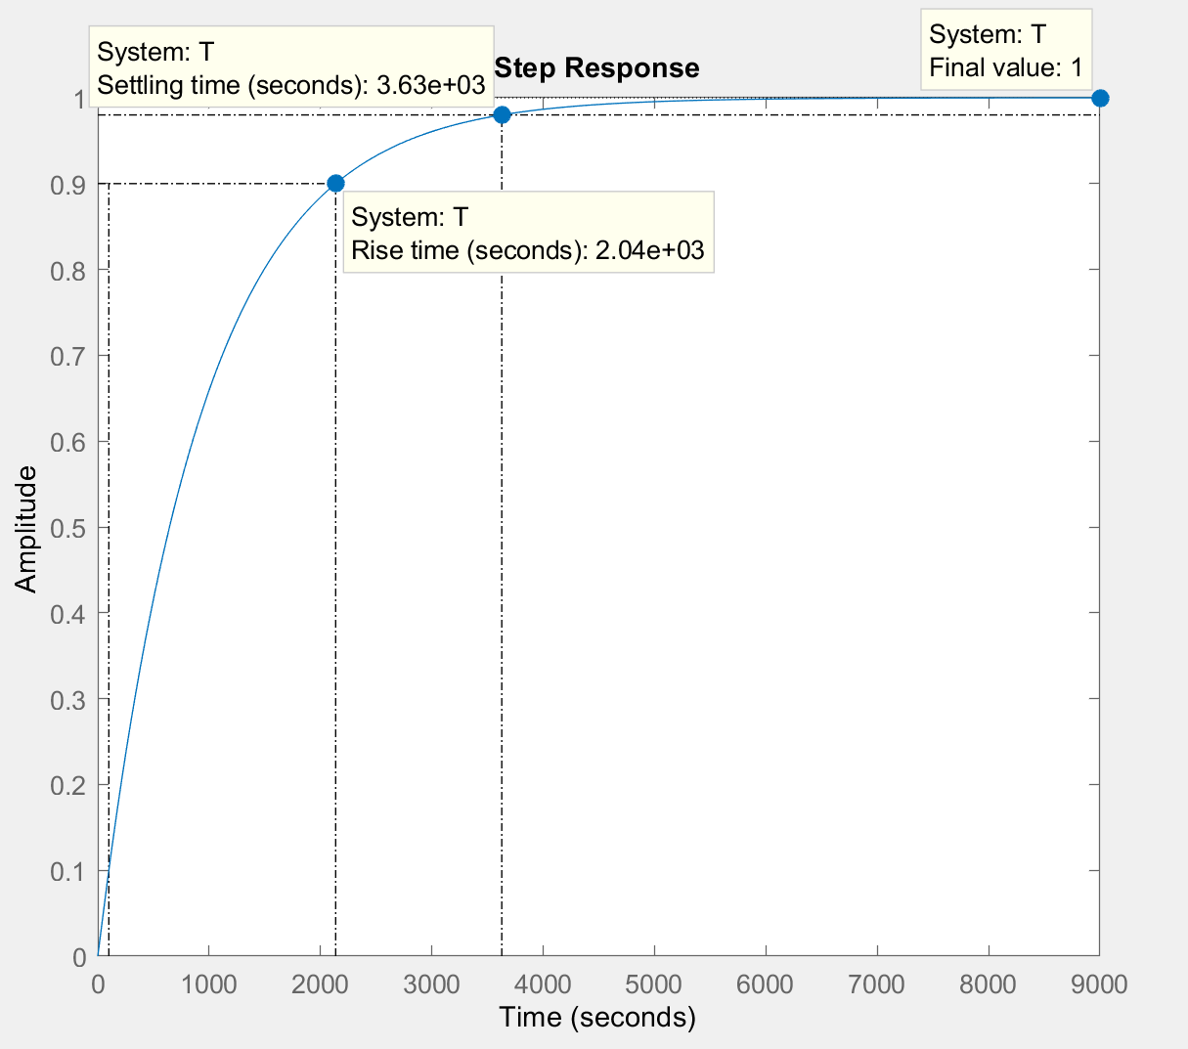

As seen from the response plot that was generated above, we note that the **rise time** and **settling time are very high (i.e. $T_{r}$ = 2040 sec and = 3630 sec)**. Thus, it has been determined by analyzing the uncompensated system, that the **settling time** and the **steady state error ($e_{ramp})$** being very high, need to be improved. The performance of these parameters can be improved by adding compensators into the system, which will be explained next.

**System Design with Lag Compensation**

The name lag compensator comes from the fact that the typical phase angle response for the

compensator, is always negative. In the book and throughout the world they refer to compensators as controllers, and I would assume is why lag compensators are commonly referred to PI controllers.

Either way, the following plot displays the closed-loop step response, and this the resulting output, where the gain was to choose to be **K = 1** andthat was chose to meet steady-state error requirements. The main point for this part of the design process is to add lag compensators to the system for improving steady state performance along with providing a faster response. Below contains the analysis and design of the lag compensator and the compensated system.

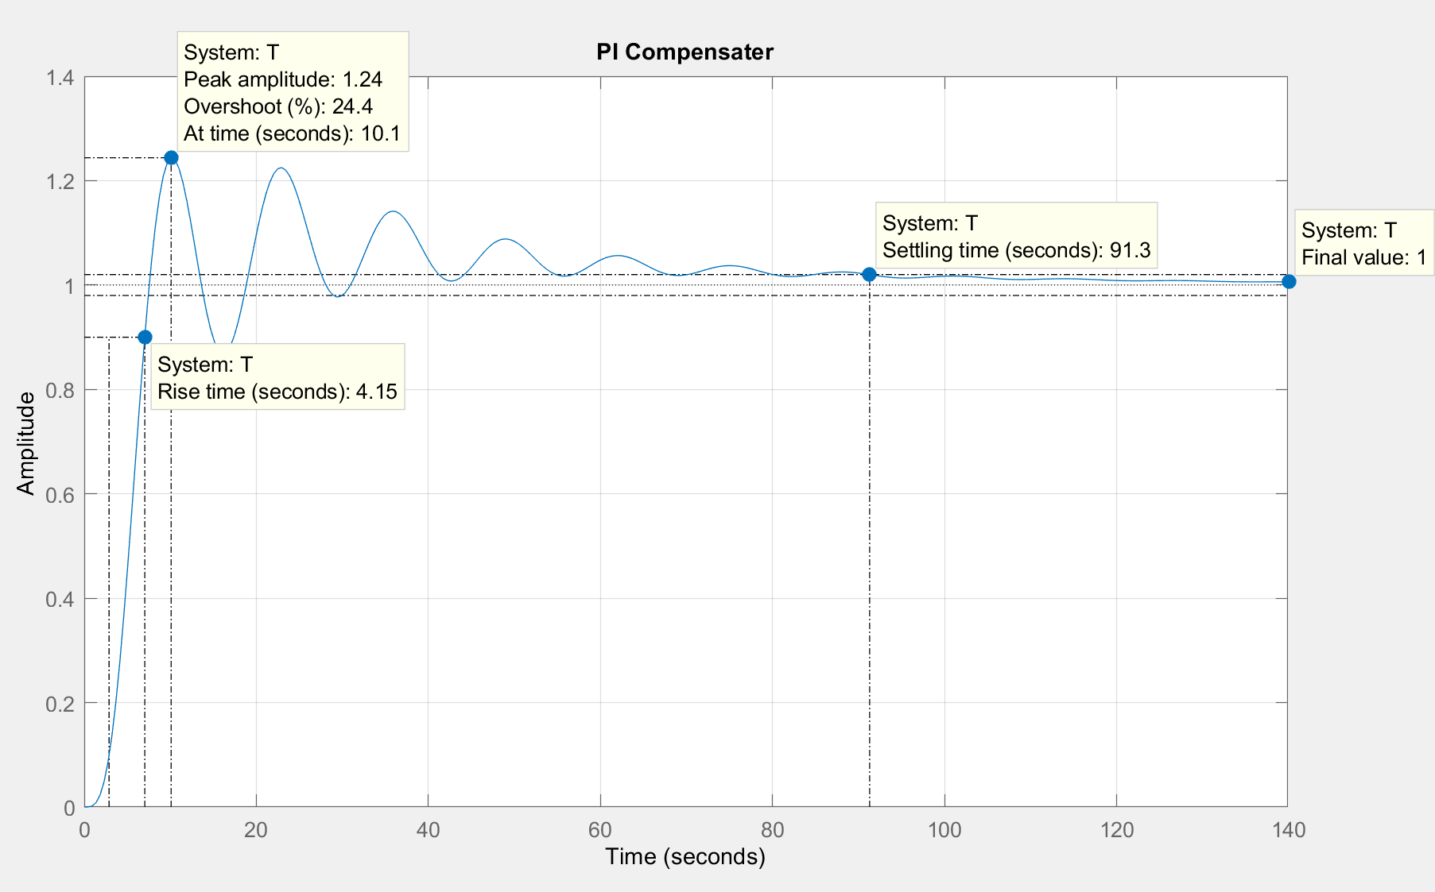

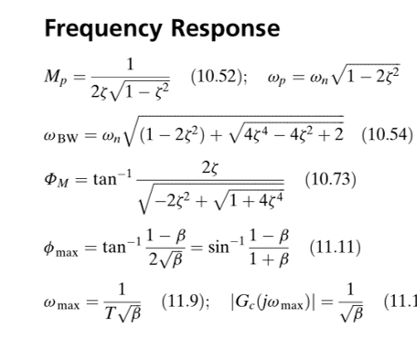 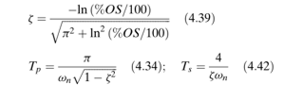

These equations were used to find the values to following system parameters, and are equivalent to the simulation values that MATLAB provided by the plot given previously.

**Percent Overshoot** = 10%,

**Damping Ratio** = 0.591155,

**Phase Margin =** 68.5988 deg,

**Ph** = 68.5931-180 = -111.4069deg

**Settling time** = $T_{s}=91.3$ sec 🡪 try to increase this with PD design

**Rise time** = $T_{s}=$ 4.15 sec

**Frequency** = 0.209 rad/sec

**Peak Time = $T_{p}=$** 32.215 sec -🡪 calculate this value

**Calculate Bandwidth =** 0.1625 rad/sec 🡪 same with this value

**Zeta = PM/100 =** 0.68588

**Magnitude = 0.00583591 🡪 Magnitude (dB) = -44.6778**

**Kc = 171.3528**

**PI Compensator: The proportional integral compensator was derived and is given by…**

$$Gpi\left(s\right)= \frac{171.4*\left( s + 0.02095906\right)}{s}$$

It also follows that the plant of the elevator when cascaded with the new controller is given below as

By cascading the plant with the controller yields that following transfer function,

$$Ge\left(s\right)=G(s)*Gpi(s)=\frac{0.097753*(s+0.02091)}{s^{2}\left(s+1.854\right)\left(s^{2}+ 0.3095s + 0.2857\right)}$$

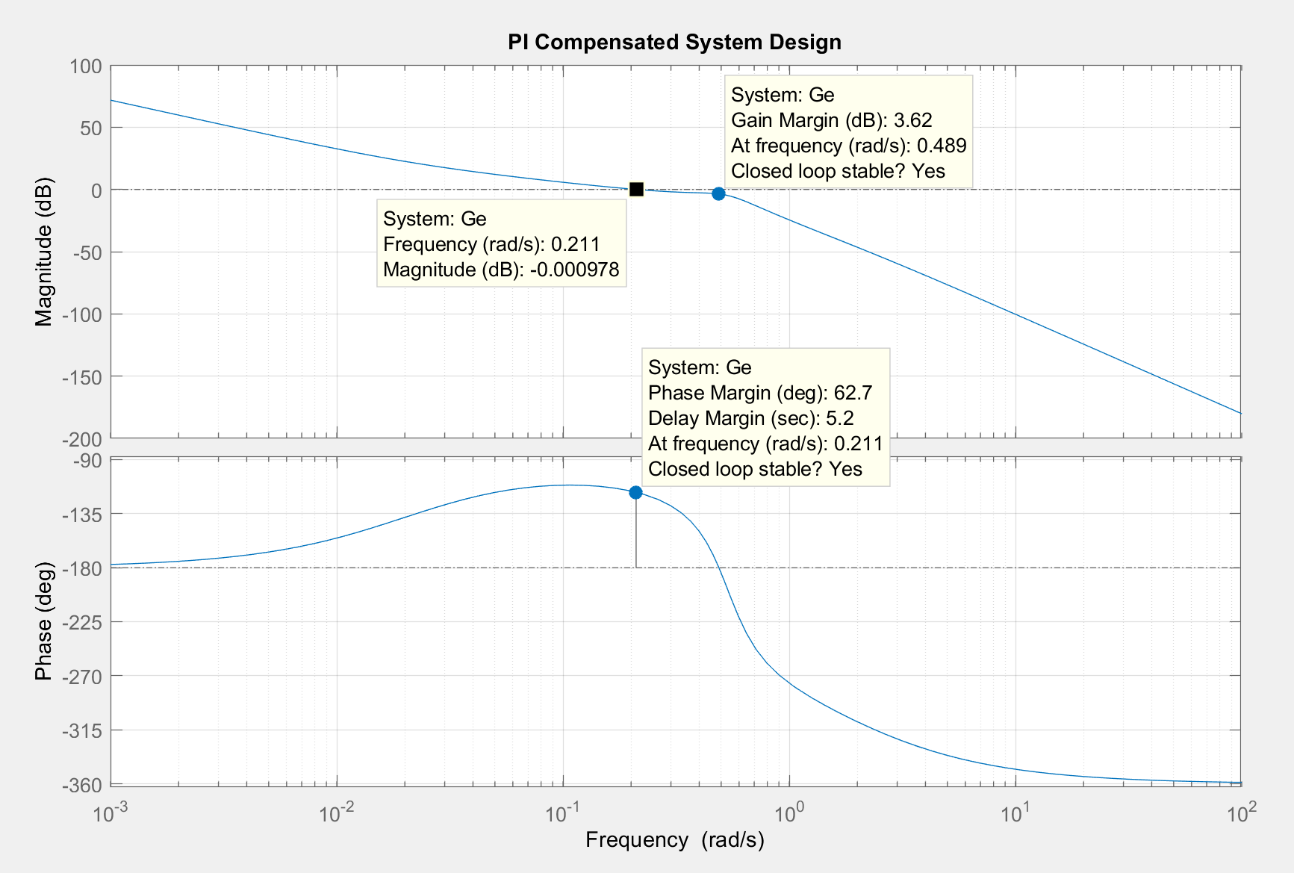

The PI Controller that was added on to the system by adding, which also added one to the system type, making the system a **type 2 system**.This was a good addition that the system needed, which has created a **slower response** and providing more overshoot, versus having a quicker respsonse which could potentially hurt or injure a rider on the elevator. **This additional steady state constant added into the system** **will provide a slower response by improving the steady state performance, but only due to the cost of slowing down the settling time.**

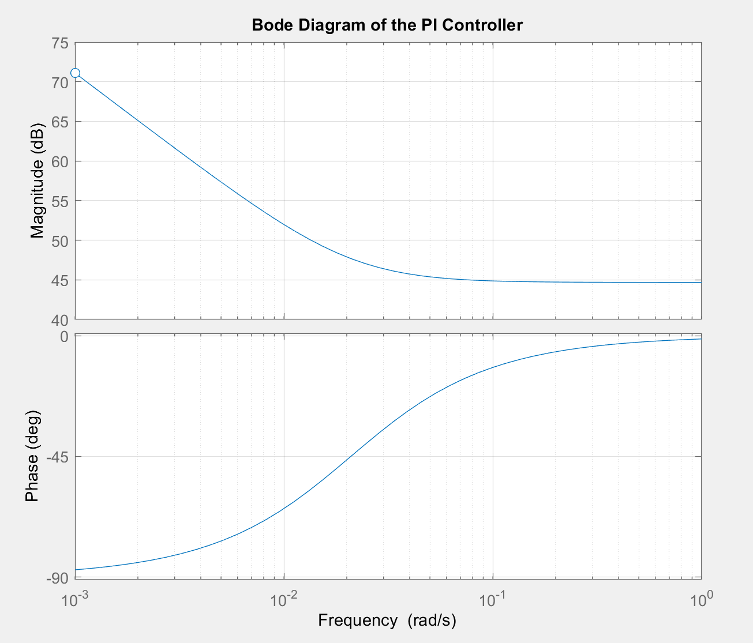

**System Design with Lead Compensation**

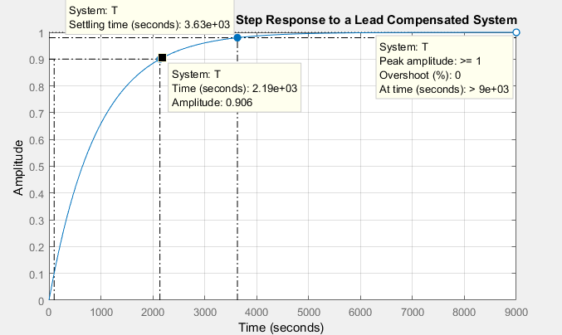

It can be said that there are no improvements by adding a lead compensator or any additional help to the steady state performance.

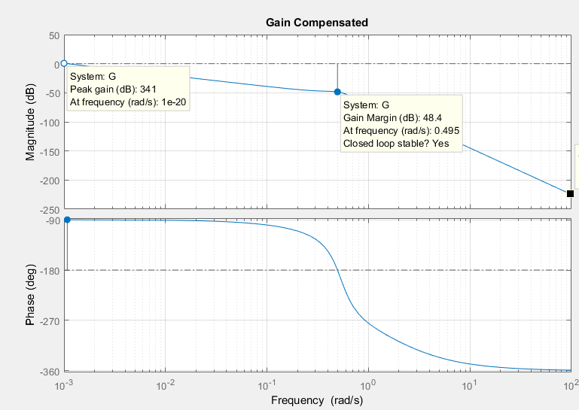

**Conclusion**

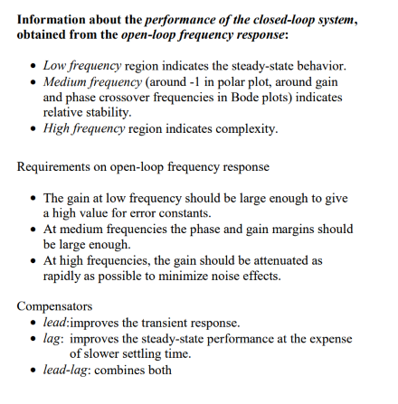

Comparison between lead and lag compensators:

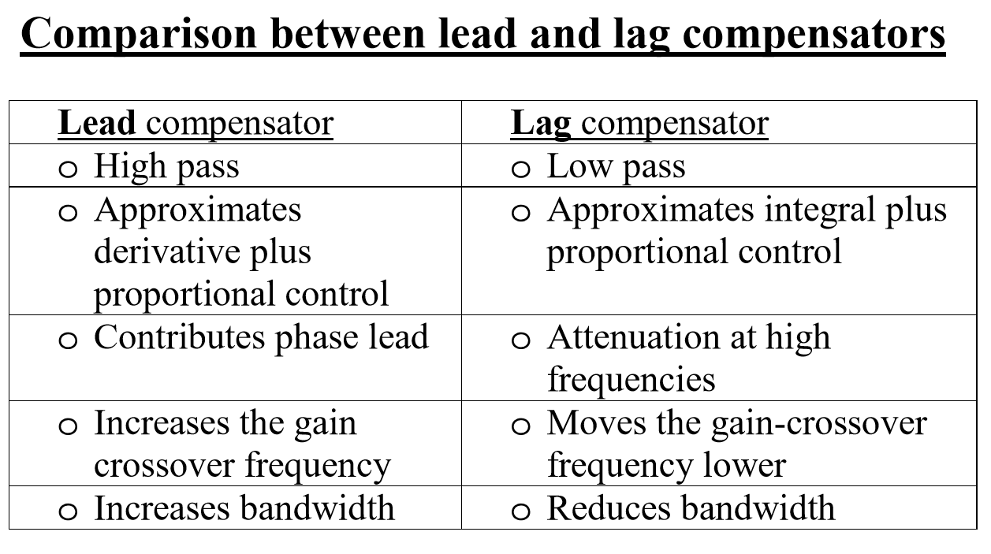

**State Space System Analysis and Design**

**Introduction to State Space System Analysis and Design**

The modern-day elevator control system uses an actuator to drive a process, the process is normally a pulley and the actuator a DC motor, these two critical parts of the system exist in the forward path and make up the plant when cascaded together. The purpose of this system is for the positioning of the elevator and is accomplished by using a proper speed reference or pattern that provides the speed profile required to move the elevator car from the departure floor to the arrival floor in the minimum possible time with minimal discomfort to the passengers.



Figure 0. *Generic physical configuration for the common elevator*

Modeling a control system in the time domain by using state space representation, is another tool that an engineer can use to gain more insight of the behavior of the control system that is being analyzed or designed. State space representation can provide the engineer with knowledge on whether the system is controllable or not. In general, if an input to a system can be found that takes every state variable from a desired initial state to a desired final state, the system is said to be controllable; otherwise, the system is said to be uncontrollable. State space representation is also useful for modeling MIMO (multiple inputs multiple outputs) systems, non-linear systems, and time-varying systems. State space representation can also be used to represent control systems in alternative forms, which will be seen later on in the report with multiple state space representations of the elevator control system. Alternative forms for representing the system is useful for identifying state variables with physical parameters and for the ease of solution of some representations. Multiple state-space representations will be used to model the DC Elevator Feedback Controller throughout this report. The following figures and equations will be referred to throughout the report and are displayed below and in the Appendix. These figures and equations are here to provide the reader with a better understanding of the physical control system that is being modeled and designed.



**Transfer function of the Actuator: $G_{m}\left(s\right)=\frac{0.001615}{s*(0.5393*s+1)}$**

**Transfer function of the Process: ${ G}_{p}\left(s\right)=\frac{8}{42s^{2}+13s+12}$**

**Plant Transfer Function**







Figure 4. *Physical schematic of elevator system*

**State Space Model in Phase Variable Form**

The phase variable form is the desired form for representing the uncompensated elevator control system to meet the design criteria for this section. The Using the transfer function of the system plant, the corresponding system representation consists of state variables that are successive derivatives of each other. The elevator’s system plant is a 4th order system and so it has 4 state variables. The resulting phase-variable representation for the plant in 4-dimensional state space is



In general, a system can be represented in state space by the following equations:

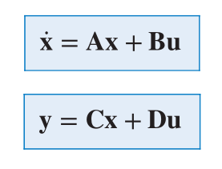

Where the system parameters of these matrix equations are described below:

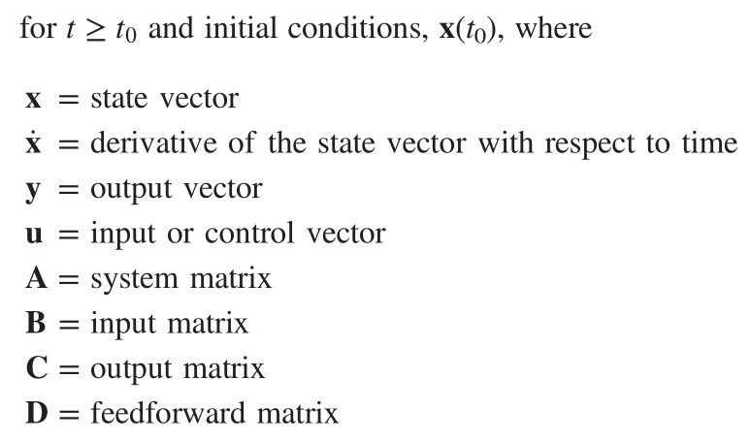

The following **hand calculations** verify the **phase-variable form representation of the uncompensated system’s plant (**refer to *figure 3 in the Appendix***)** that was previously displayed.



Using the values from the previous result, we note that the A, B, C, and D matrices can be found.

 

The previous hand calculated result leading to the **phase-variable form of the uncompensated system’s plant** result is now verified by **MATLAB computations** which are displayed by the output matrices seen below.

MATLAB output verifying the **phase-variable form of the uncompensated system’s plant:**

A =

0 1.0000 0 0

0 0 1.0000 0

0 0 0 1.0000

**0**  -0.5298 -0.8597 -2.1638

B =

0

0

0

1

C =

**0.0005705** 0 0 0

D = 0

The resulting output representing the system’s plant in phase variable form provided from MATLAB is the same as the result provided by the hand calculations, other than **C[1,1] is approximated to 0 during the hand calculations**, versus MATLAB output for **C[1,1] = 0.0005705.** This floating-point precision is to be expected with making computations using computer software such as MATLAB. However, due to the negligible effect of this parameter given that it is very small and considering the controllability of an elevator system, we will neglect **C[1,1]** by rounding it off to zero. Thus, for our purposes we let **C = [0 0 0 0]** during the analysis of the phase variable form representation of the system’s plant.

The next computation performed in MATLAB displays the result of the phase-variable representation of the system’s plant from above, but now with an added unity gain feedback. Thus, making it a closed-loop system as seen with *figure 3 in the Appendix*.

**Matrices A, B, C, and D in phase-variable form representing the closed loop system with unity feedback are given below.**

A =

0 1 0 0

0 0 1 0

0 0 0 1.0000

***-0.0006*** -0.5298 -0.8597 -2.1638

B= 0

0

0

1

D = 0

C =

0.0005705 0 0 0

It is interesting that there is hardly any difference when comparing the phase-variable representation of the closed-loop system when compared to the open loop system that was previously seen when observing the plant. The only slight difference took place between the closed loop and the open loop system when analyzed in phase variable form, could be seen in the A matrix located in the A[4,1] element. This value is A[4,1] = -0.0006 for the closed-loop system and A[4,1] = 0 for the open loop system. This was the only evident difference between the system parameters when comparing the closed loop system to the open loop system in phase-variable form. The other system parameters and variables when observed in phase-variable form are identical.

**State Space Model in Observer Canonical Form**

In the previous section the phase-variable representation was be derived directly from the plant transfer function of the uncompensated system, and the same is applied for obtaining the observer canonical form in this section, where we derive the result by starting with the plant transfer function of the uncompensated system. However, to obtain the observer canonical form we must first divide the plant transfer function through by the highest power of **s**, which was not done previously.

Thus, dividing the plant transfer function through by the highest power of **s** results in the following:



Now, cross multiplying both sides of the plant transfer function yields

$$\left(1+\frac{2.1638}{s}+\frac{0.8597}{s^{2}}+\frac{0.5298}{s^{3}}\right)C\left(s\right)= \frac{0.02396}{s^{4}}R(s)$$

Next, we combine the terms of the same powers of integration which yields

$$C\left(s\right)=-\frac{1}{s}\left(2.1638*C\left(s\right)\right)-\frac{1}{s^{2}}\left(0.8597*C\left(s\right)\right)-\frac{1}{s^{3}}\left(0.5298*C\left(s\right)\right)+ \frac{1}{s^{4}}(0.02396*R\left(s\right))$$

Now, the **state equations** are derived using the previous result. It should also be further noted that the **state variables** can be found from these equations.

$\dot{x_{1}}= {-2.1638*x}_{1}+ x_{2}$

$$\dot{x_{2}}= -0.8597{*x}_{1}+ 0 + x_{3}$$

$$\dot{x_{3}}= -0.5298*x_{1}+ 0 + 0 + x_{4}$$

$$\dot{x_{4}}= 0 + 0 + 0 + 0 +0.02396*r$$

Next, using the state variable equations, the matrices A, B, C, and D are solved for.



Finally, the observer canonical form is solved for. **The observer canonical form for the plant transfer function is shown below.**



**State Space Model in Jordan Canonical Form:**

Once again, starting with the plant transfer function of the uncompensated system (see *figure 1* in the Appendix) we can derive the desired alternative state space representation known as the Jordan Canonical Form. However, in contrary to the previously derived state space representations, to represent the system plant in Jordan Canonical form, we must first perform partial fraction expansion of the plant transfer function. This mathematical procedure is performed below.

$$G\left(s\right)=\frac{C\left(s\right)}{R\left(s\right)}=\frac{0.02396}{s*\left(s+1.8543\right)*\left(42*s^{2}+13*s+12\right)} =-\frac{0.0001}{\left(s+1.8543\right)}+\frac{-0.0005+j0.0003}{s+0.1548-j0.5116}+\frac{-0.0005-j0.0003}{s+0.1548+j0.5116}+\frac{0.0011}{s}$$

Now, using the expanded transfer function from above, we can find the state variables.

$\dot{x_{1}}= {0*x}_{1}+ { 0*x}_{2} +$ ${0*x}_{3}$ $+ { 0*x}_{4}$

$$\dot{x_{2}}= 0{*x}_{1}+ -1.8543* x_{2} + { 1*x}_{3}{ + 0*x}_{4}$$

$$\dot{x_{3}}= 0*x_{1}+ 0*x_{2} +\left(-0.1548-j0.5116\right)*x_{3} {+ 0*x}_{4}$$

$$\dot{x_{4}}= 0*x_{1}+ 0*x_{2} + { 0*x}_{3} + \left(-0.1548+j0.5116\right)*x_{4}$$

Therefore, using the state variable equations, we obtain the matrices A, B, C, and D.



Finally, the Jordan Canonical form of the plant transfer function can be derived, and is given below as



**Controller Design Using State-Space Techniques**

First, before moving on with the controller design**, we must determine if the system is controllable or not?** This can be done by analyzing the **Jordan canonical representation** of the system that was previously derived in the last section, and is displayed below for quick reference.



Thus, it can be concluded that the **system is controllable**, since there is an input for every state variable. Also, the controllability matrix has full rank, which also verifies that the **system is controllable**. Since the controllability of the system has been determined, we can now design a controller for the system.

When considering a controller design for the system, we refer to the **closed-loop response of the uncompensated system**, which is a helpful reminder of where improvements have been made previously using frequency response methods and techniques for system analysis and design, which now will be used to provide insight on how the system can be improved by using state-space design techniques to build a controller.

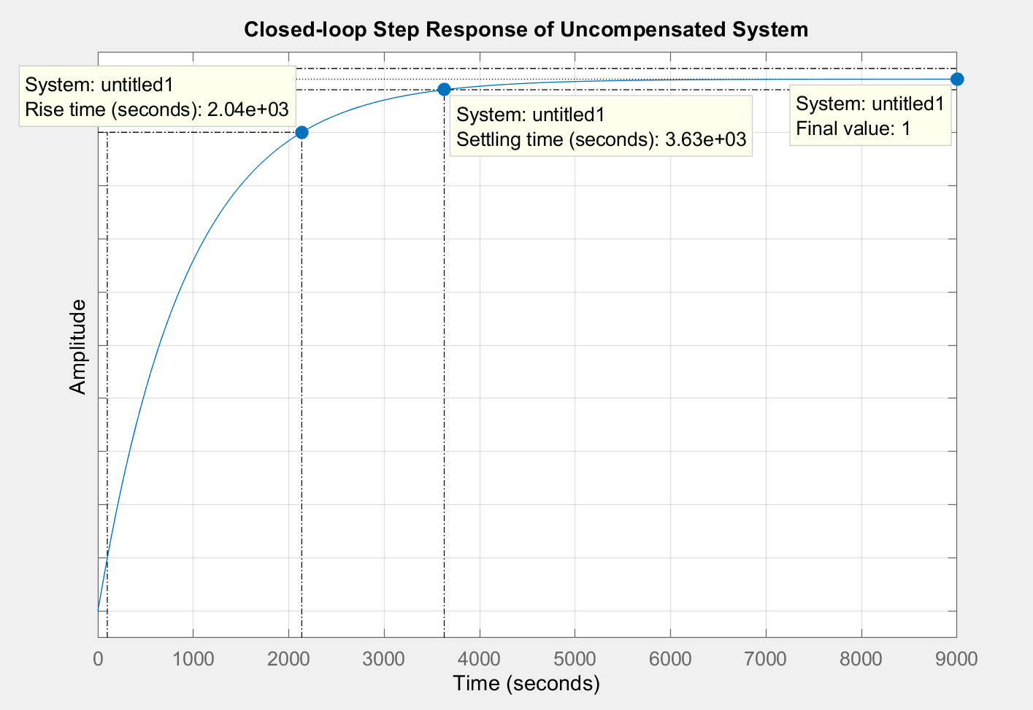

*Figure 5. Closed-loop Response of Uncompensated System*

As seen from the response plot that was generated above, we note that the **rise time** and **settling time are very high (i.e. $T_{r}$ = 2040 sec and = 3630 sec)**. Thus, it has been determined by analyzing the uncompensated system, that the **settling time** and the **steady state error ($e_{ramp})$** being very high, needs to be improved. The performance of these parameters can be improved by designing a controller, which will be explained next.

For the state-space controller design the following constraints are chosen to improve settling time, provide desired overshoot, and to speed up the system’s overall response. These constraints include:

* **The controller must yield a 10% overshoot**
* Percent overshoot %O.S. = 10%

* **The controller must provide a settling time no more than 30 seconds**
* Settling time = $T_{s}$ = 30 sec
* **The 3rd order and 4th order poles must be placed 10 and 100 times as far from the imaginary (jw) axis**

Now, the controller design begins. The steps of the design process for the controller are given below:

Using the controller design constraints as specified previously along with the following equations representing the systems time response, the desired characteristic equation and related system parameters are calculated below using the following equations.

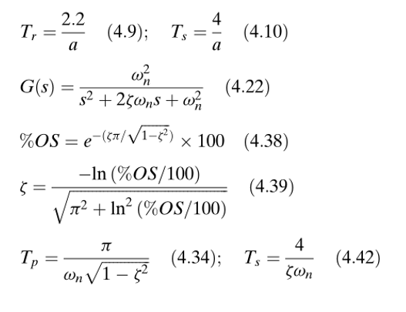

$Damping Ratio= ζ= -\frac{\ln\left(\frac{10}{100}\right)}{{\left(π^{2}+{\left(ln\left(\frac{10}{100}\right)\right)}^{2}\right)}^{\frac{1}{2}}}$ = **0.5912**

$Natural freq.= ω_{n}= \frac{4}{0.5912*30}$ = **0.2255 rad/s**

The generic 2nd- order representation of a system’s transfer function is used below to model the ideal plant, and

is used to solve for system parameters that are directly related to the constraints, as previously stated.

Ideal 2nd Order transfer function 🡪

Now, the dominant poles of $Gi\left(s\right)$ are given by setting the denominator of Gi(s) equal to 0, and solving for s.

Therefore, the dominant poles are located at **s = - 0.1333 ± j*(0.1819) .**

After placing the 3rd and 4th order poles of Gd(s) the proper distance away from the jw-axis, the following desired closed-loop transfer function now becomes a 4th order system, matching the order of the

uncompensated system’s plant transfer function. Therefore, the following transfer function is the desired model

that will be used to provide a way to mathematically solve for each of the variable gains that will soon be added

to system’s plant.

$$Gd\left(s\right)=\frac{0.05087}{{(s+1.3334)(s+13.3343)(s}^{2}+0.2667*s+0.05087)}$$

Hence, the desired characteristic equation for the closed-loop system Gd(s) is

${(s+1.3334)(s+13.3343)(s}^{2}+0.2667*s+0.05087)$ =0

$s^{4}+14.9344*s^{3}+21.7425*s^{2}+5.4879*s+0.9045=0$

Next, we find the actual characteristic equation of the closed-loop system. The first step is to model the closed-

loop system in state-space and then to find its characteristic equation. From the appendix the plant transfer

function of the uncompensated system is



Now we convert the plant transfer function G(s) to phase-variable form (this was previously derived).



The next step is to feedback each phase variable to the input of the plant through a gain, **ki.**

Where, the closed-loop system is formed by feeding back each state variable to u, forming

u = **-Kx** ;  **K** = [k1 k2 … kn]

Thus,

**A-BK =** 

Since **A-BK** is in phase-variable form, the characteristic equation of the closed - loop system can be written by

inspection as

det(s**I-(A-BK)**) = $s^{4}+\left(2.1638+k_{4}\right)*s^{3}+\left(0.8597+k_{3}\right)*s^{2}+\left(0.5298+k_{2}\right)*s+k_{1}=0$

Now, this equation must match the desired characteristic equation,

$$s^{4}+14.9344*s^{3}+21.7425*s^{2}+5.4879*s+0.9045=0$$

Therefore, by equating the coefficients of the last two equations, we obtain

$$\left(2.1638+k_{4}\right)=14.9344 ; \left(0.8597+k_{3}\right)=21.7425 ; \left(0.5298+k_{2}\right)=5.4879 ; k_{1}=0.9045$$

Thus, the phase-variable feedback gains are given as

$k_{4}=12.7706 ; k_{3}=20.8828 ; k_{2}=4.9581 ; k_{1}=0.9045$

Therefore, the following state-space representation of the closed-loop system has been obtained.



Finally, the resulting closed-loop transfer function is given by,



Now in testing the new compensated closed-loop system, where the new transfer function is T(s), we see that the closed-loop step response of the compensated system is displayed by the by the MATLAB plot below.

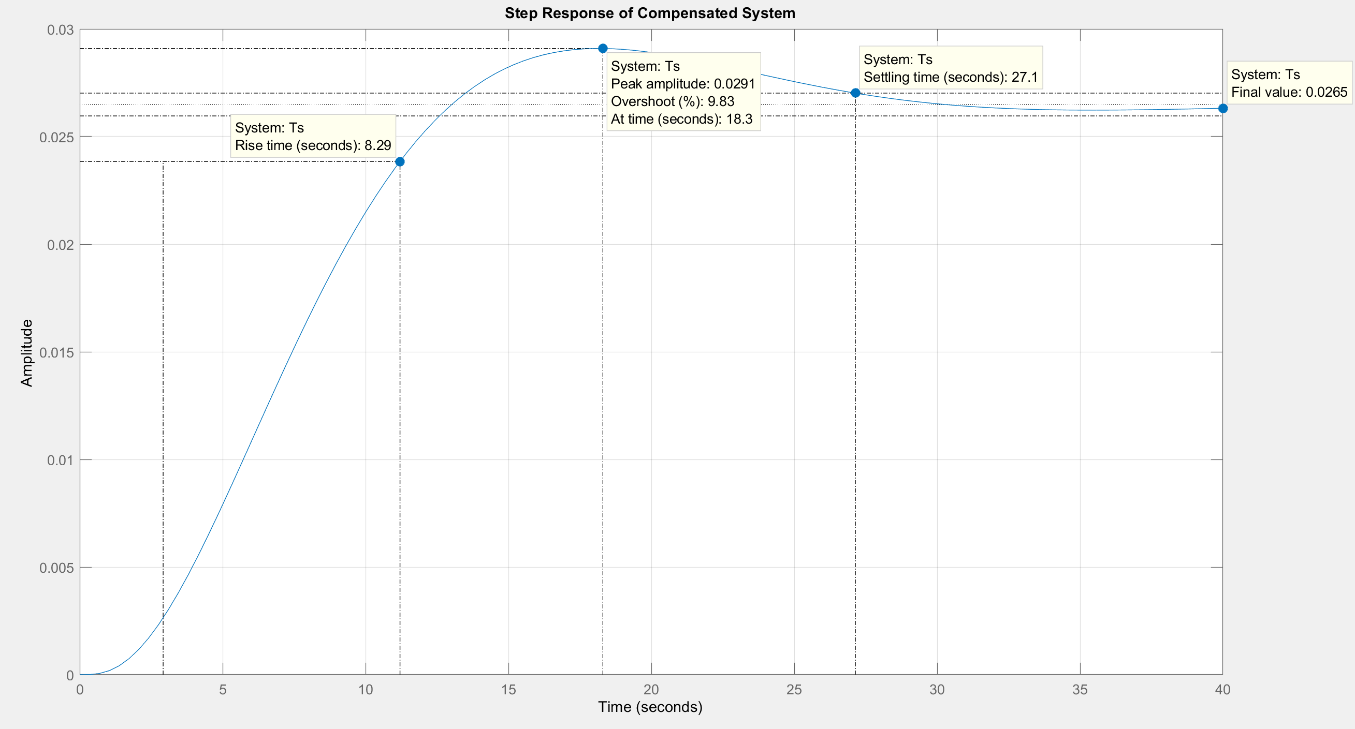

*Figure 6. Step Response of the Compensated System*

The controller that was added to the **system improved the settling time to 27.1sec**, and it **increased the**

**percent overshoot to 9.83%**. **This controller brought much improvement to the system**. **The systems**

**response became faster, and the overshoot increased to approximately the desired value after one**

**iteration.** This design of the controller in state-space was a success.

**Observer Design Using State Space Design Techniques**

Before designing the observer for the system, we first test the system for observability. Observability of a system can be easily determined using the observability matrix. This allows for the designer to see if the system is observable or not. Observability of the system must be verified, otherwise observers cannot be designed. The **observer canonical form** for the **plant transfer function of the uncompensated system** is shown below and was previously derived.

 

Now performing the matrix computations as seen below we obtain the controllability matrix $O_{M}$.



$O_{M}=$

Now, by taking the determinant of $O_{M}$, we see that the **system is observable, since the determinant of $O_{M}=1$** . Therefore, the observability matrix $O_{M}$ is of **full rank,** where the **rank = 4.** Thus, the **system is observable**, and now we can move forward with designing an **observer** for the system to meet the state-space design requirements.

An **observer** in state-space design can be used for estimating the state variables using information from the output of the system’s plant. Observer design consists of feeding back the error between the actual output and the estimated input.

**As previously seen, the state-space controller that was designed had greatly improved the system’s performance. Thus, we will use the same constraints for designing the observer**. Using the same design constraints should provide insight into discerning the differences between the controller versus the observer design, and it should uncover which state-space design method is better suited for my elevator control system.

Thus, using the same constraints as before, we need to design an observer that is capable of providing **10% overshoot and a settling time of 30 seconds** for the new compensated system using. Since, the design constraints are the same as with the controller, we know that the ideal transfer function that was previously derived will be the same.

Ideal 2nd Order transfer function 🡪

Therefore, the dominant poles are located at **s = - 0.1333 ± j*(0.1819)**

Hence, the desired characteristic equation for the closed-loop system Gd(s) is

${(s+1.3334)(s+13.3343)(s}^{2}+0.2667*s+0.05087)$ =0

$s^{4}+14.9344*s^{3}+21.7425*s^{2}+5.4879*s+0.9045=0$

Now using the observer canonical form of the plant, we can form the difference between the plant’s actual output y, and the observer’s estimated output, $\overbrace{y}$, and add the feedback paths from this difference to the derivative of each state variable.

Thus, the following characteristic equation is given by

$det⁡(λI-(A-LC))$**= 0**

Now we select the eigenvalues of the observer to yield stability and a desired transient response that is faster than the controlled closed-loop response. These eigenvalues can be used to determine a characteristic equation that we can set equal to $det⁡(λI-(A-LC))$ and solve for **L**.

However, to obtain the eigenvalues we must first solve for **A – LC** .The following procedure from the textbook is followed to obtain the desired result,



Thus, the characteristic equation for $A-LC$ is given by the following,

$$s^{4}+\left(2.1638+l_{1}\right)*s^{3}+\left(0.8597+l_{2}\right)*s^{2}+\left(0.5298+l_{3}\right)*s+\left(0+l_{4}\right)=0$$

Now using the **desired closed-loop equation Gd(s)** and the **characteristic equation for A-LC** that were calculated previously, we can equate the coefficients of these two equations, allowing us to solve for $l_{1} , l_{2 }, l_{3 }, and l_{4}$ simultaneously.

Therefore,

**🡪**

**🡪**

**🡪**

**🡪**

**Now, it is clearly seen that the values for $l_{1} , l_{2 }, l_{3 }, and l_{4}$ are identical to the values of k, where $k_{4}=12.7706 ; k_{3}=20.8828 ; k_{2}=4.9581 ; k_{1}=0.9045$ that were solved for previously, when the state-space controller was designed.**

**Therefore, we have no need to continue designing an observer for the system, because the result would be the same that has already been derived by the design of the controller in state-space.**

Thus, it makes no sense to continue in designing an observer, and so we discontinue any further state-space design.

**Appendix**

**Equations and System Functions:**

Transfer function of the Actuator: $G_{m}\left(s\right)=\frac{0.001615}{s(0.5393s+1)}$

Transfer function of the Process: ${ G}_{p}\left(s\right)=\frac{8}{42s^{2}+13s+12}$

Plant Transfer Function:****



Transfer function of the new compensated system, that was derived by designing a controller to meet state-space constraints:



**Appendix (cont.)**

**Figures:**



Figure 0. *Generic physical configuration for the common elevator*









Figure 4. *Physical schematic of elevator system*

**Physical Build Implementation of System**

